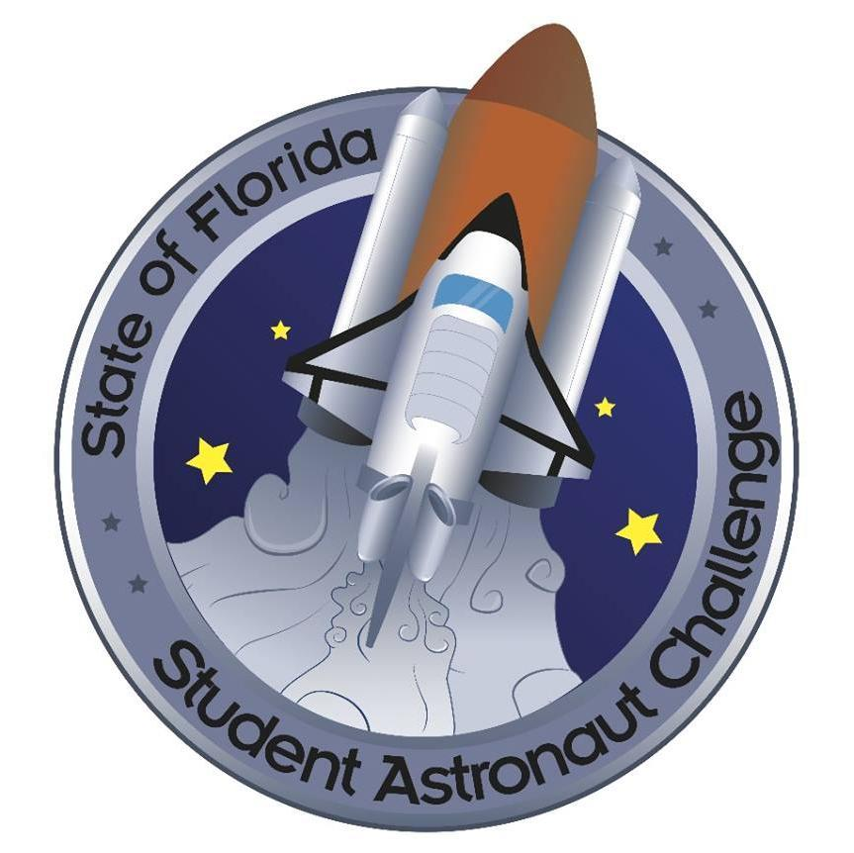SMMS Astronaut Club 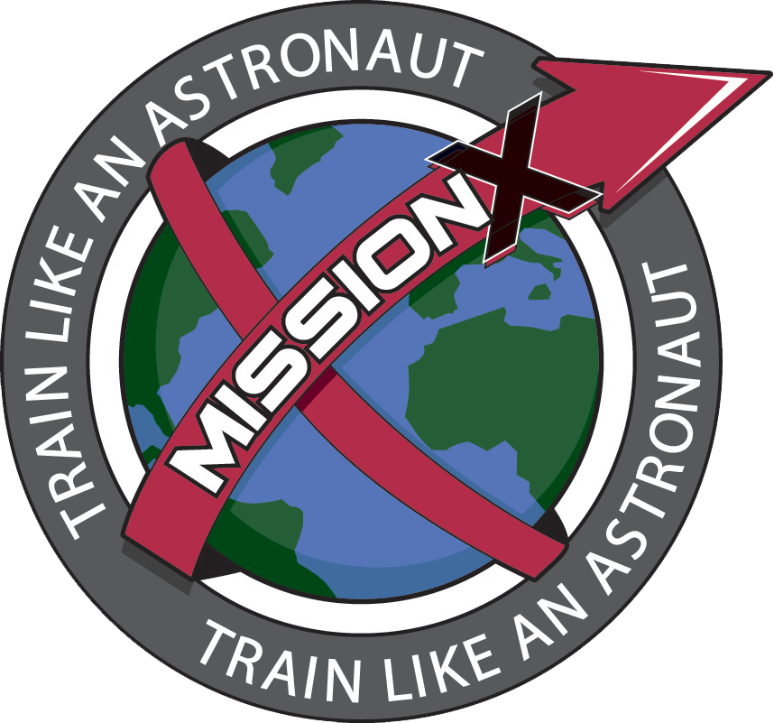 The SMMS Astronaut Club is comprised of 2 levels of participation:

- The Student Astronaut Challenge is a 5 person competition team(s) that meet weekly to study and practice for the challenge. The competition team(s) will begin meeting 8/30. You will need to apply for the competition team. The students will be studying for and competing in mock simulations of space shuttles missions, International Space Station Experiments, and moon Orbiter missions.

- The SMMS Astronaut Club is open to anyone wanting to learn about aeronautics and challenges with space flight. We will explore engine systems, water recycling, aeronautic designs, and many other design and flight investigations that engineers and astronauts face. The open club will begin meeting in October.

Coach: Mrs. Angel Alexander, Alexander.angel@brevardschools.org
Meetings are held in room 103. Class number is (321) 723-0741X5103

Calendar of events:
COMPETITION TEAM PRACTICES are on Wednesdays: 3:15- 5:30pm
August: 23rd, 30th
September: 6th, 13th, 20th and 27th
**September 23rd is regionals Depending on regional results- we will be notified by 10/14 if we advance to state which takes place February 19th- 21st, 2018 at Kennedy Space Center.

OPEN CLUB MEETINGS:
October: 4th, 11th
November: 1st, 8th
December: 6th, 13th
January: 10th, 24th, 31st
February: 7th, 14th, 28th
March: 7th, 14th, 28th
April: 11th, and 25th (last meeting is 4/25)

**Your child is expected to help fundraise to support the efforts and supplies cost of the club activities. There are 3 throughout the year. (Fun Pasta, Java Joe’s Coffee, and Natures Vision)

