Standards Based Instruction

Standards based instruction is a process for planning, delivering, monitoring, and improving academic
programs in which clearly defined academic content standards provide the basis for content in instruction and assessment.

In Brevard, elements of standards based instruction include:
- Instructional rigor is the goal of helping students develop the capacity to understand content that
is complex, ambiguous, provocative, and personally or emotionally challenging. It is not about level of difficulty.

- Student engagement is the level of personal investment students devote to educationally
purposeful activities that increase intrinsic motivation. Engaged students access prior knowledge,
pursue meaningful challenges, initiate deep, thoughtful actions, persist despite obstacles, and contribute directly to desired learning outcomes.

- Alignment requires an understanding of the depth of the standards for the purposes of
lesson planning, instructional delivery, and progress monitoring leading to student mastery
of the content described in the course description.

- Progress monitoring is the evidenced-based, ongoing practice of assessing students' academic
performance to determine whether they are making appropriate progress in a standards-based
curriculum, and to evaluate the effectiveness of instruction, e.g. formative assessment, interim assessment, etc.

*Definitions sourced from the Florida Department of Education's, "Common Language of Instruction," DOE Form#EQEVAL-2012-4.

WHAT?

Standards Based Instruction and
Quality Learning Environment

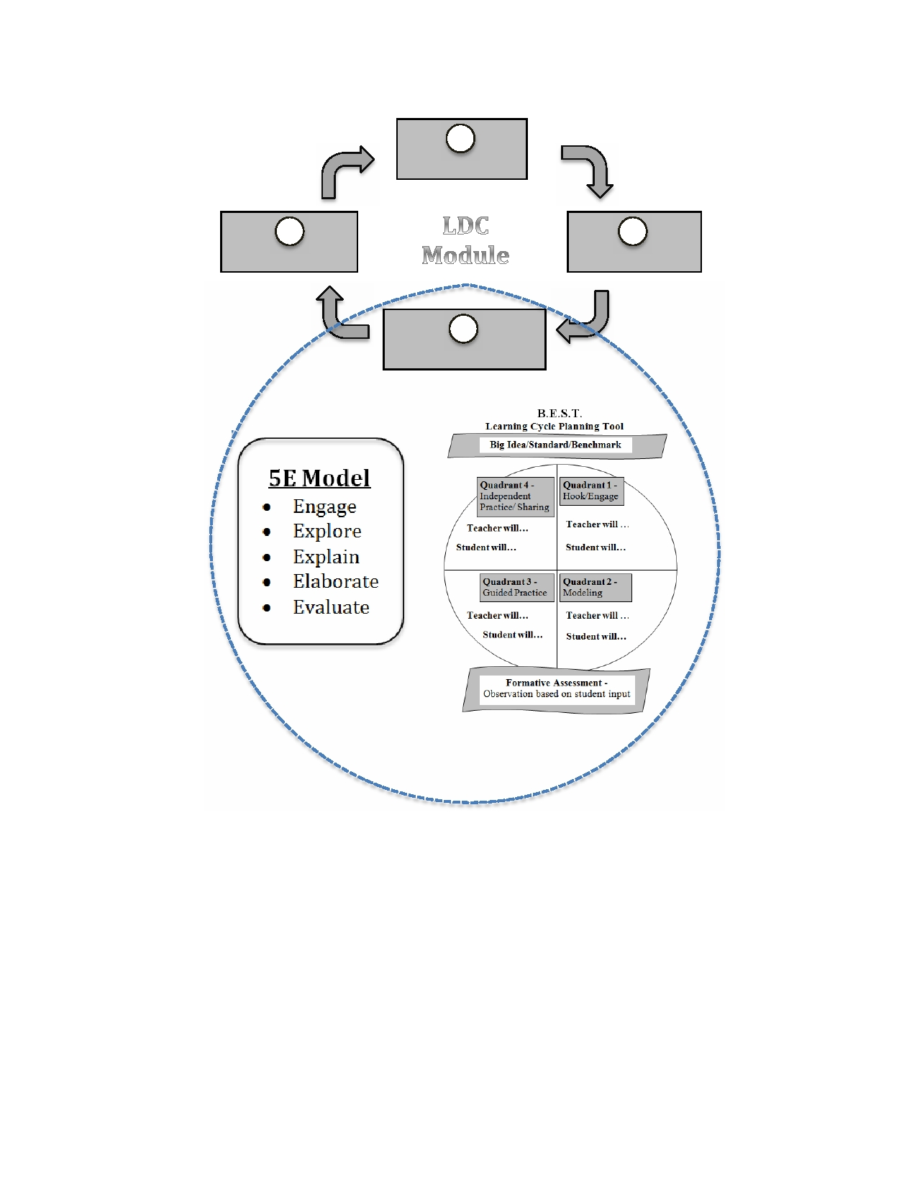
HOW?

1
What task?

4
What results?

3
What instruction?

2
What skills?

