Brevard Public Schools Secondary Mathematics Tournament – April 12, 2014
Written Test Division 2 – Algebra 2 and Pre-Calculus
Answer Sheet – Please put answers only to all questions from the written test in the box provided.
SCHOOL ____KEY_______________________ GRADER 1 INITIAL__________ SCORE_________
SUBJECT ALGEBRA 2 & PRECALC GRADER 2 INITIAL__________SCORE__________
(If needed) GRADER 3 INITIAL__________SCORE__________

1. | (R ▫ S)(20,500) by $200 | 7. | ≈ 444.1 feet (rounded)
2. | $\frac{12}{17}$ | 8. | 1st: 36 30th : 2124
3. | –256 | 9. | ±1
4. | 1287 | 10. | $\frac{3+ \sqrt{3}}{3} OR 1+ \frac{\sqrt{3}}{3}$  (simplest radical form)
5. | 850 km/h | 11. | 9
6. | Equation: h = 9 sin$\frac{2π}{7}t$ + 46 .  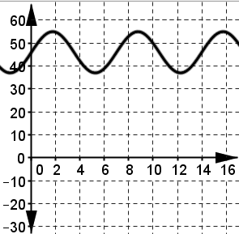 | 12. | $1020
 |  | 13. | 1st: Cheryl  2nd: Richard  3rd: Derek
 |  | 14. | 5 + $\sqrt{19}$ (exact)
 |  | 15. | 2
16. | $\frac{5\sqrt{2}}{2}$ (exact simplified) | 21. | –24
17. | 85$\frac{1}{3}π$ OR $\frac{256π}{3}$ (exact) | 22. | 8 in.
18. | 4 | 23. | 2
19. | $-\frac{33}{5}- \frac{119}{5}i OR -6.6-23.8i$ | 24. | 0.48 gallons OR 0.5 gallons
20. | 14 m

